

Sri Lanka Institute of Information Technology

**Electronic Shop System**

Paper Prototypes

Information Technology Project (IT2080)

2018

Project ID :- ITP-2018-MLB-G1-15

Submitted by:

1. IT16178700 – D.I.K. Rajapakshe
2. IT17018760 – M.P.P. Shamil
3. IT16067370 – Rathnayaka M.H.K.R
4. IT17015172 – Subasinghe R.S.R.M.D

This is the ITP our Paper Prototypes video link : - <https://youtu.be/kOlQ2MmLVN4>

1. **Add Invoice**
2. Loading system.
3. Display Login page.
4. Cashier entering User type.
5. Entering username and password.
6. Checking username and password.
7. Display login successful message.
8. Display home page.
9. Click Invoice Management.
10. Select Add Invoice.
11. Display Bill Panel.
12. Display bill details.
13. Entering customer details.
14. Entering Order Details.
15. Display Items Details.
16. Click Add button.
17. Adding order to the bill table.
18. Showing order in table.
19. If cashier click Void button will displayed admin login to confirm to remove item in the table.
20. Removing selected item in the table.
21. Entering Payment details.
22. Choosing payment mode.
23. Click Proceed button.
24. Checking bill details.
25. If choosing full cash payment mode payment page.
26. Entering cash money.
27. Without entering cash up to total amount cannot submit payments.
28. Calculating change and system display change in the payment page.
29. If choosing check payment mode display the check page.
30. If choosing credit/debit payment display the credit/debit payment page
31. After entering details and validating cashier clicking Print bill.
32. Displaying customer bill.

5A. If username or password invalid display error message.

5B. Re-enter username and password.

15A. If current stock not available to entered order system will display error message.

23A. If invalid details display error message.

01

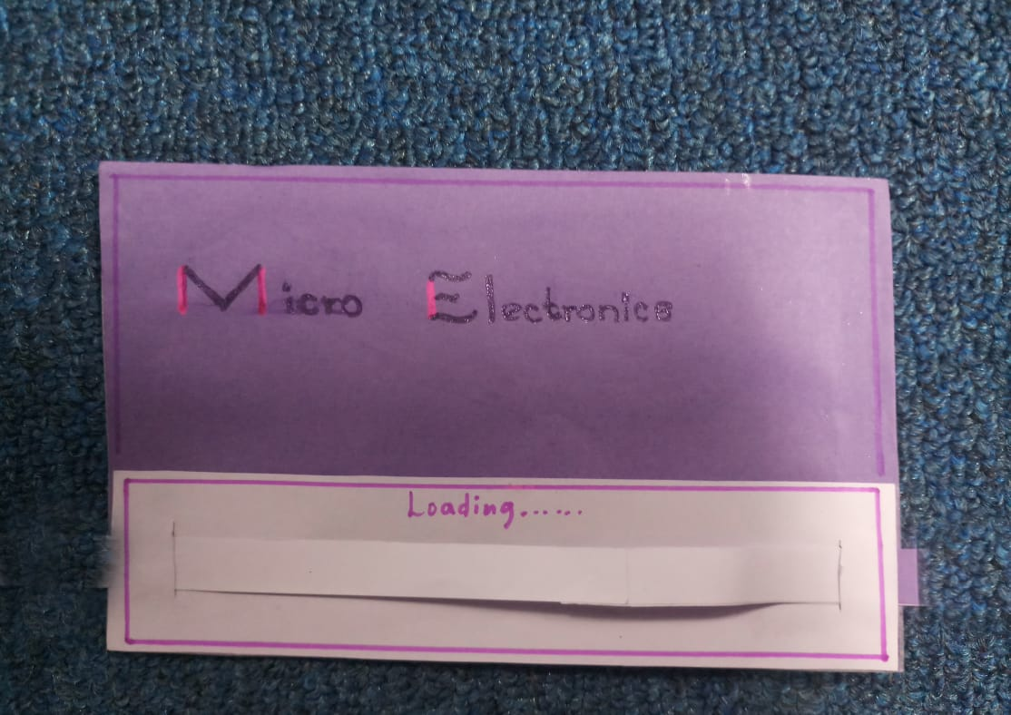

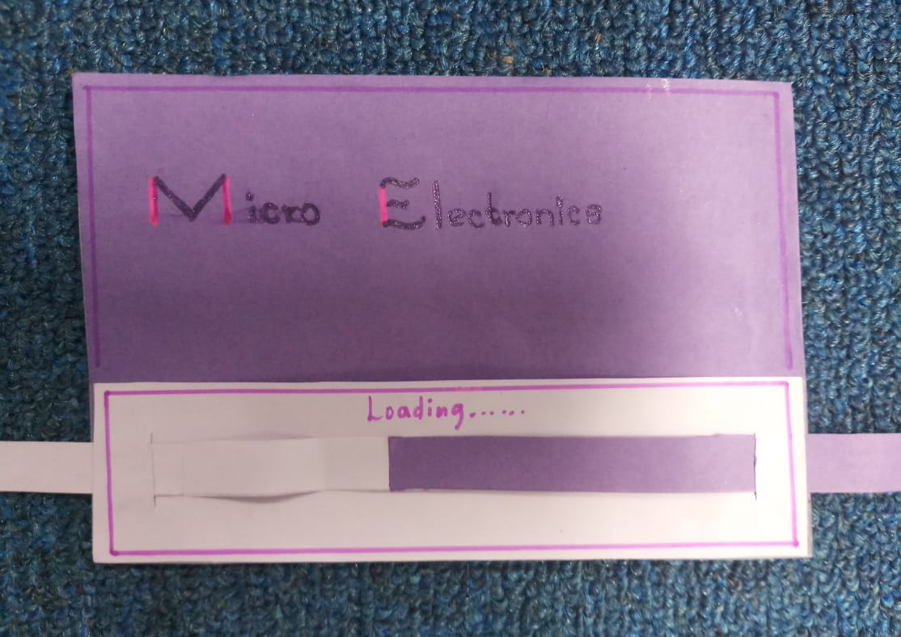

02

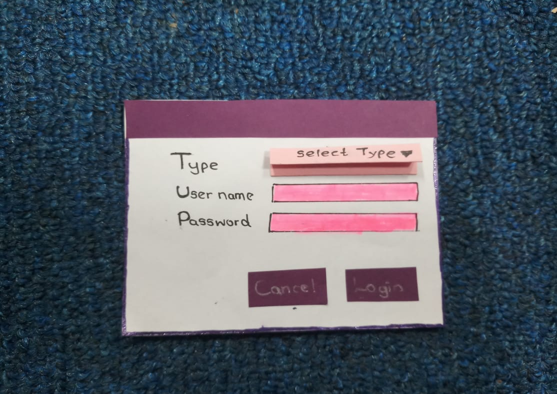

03

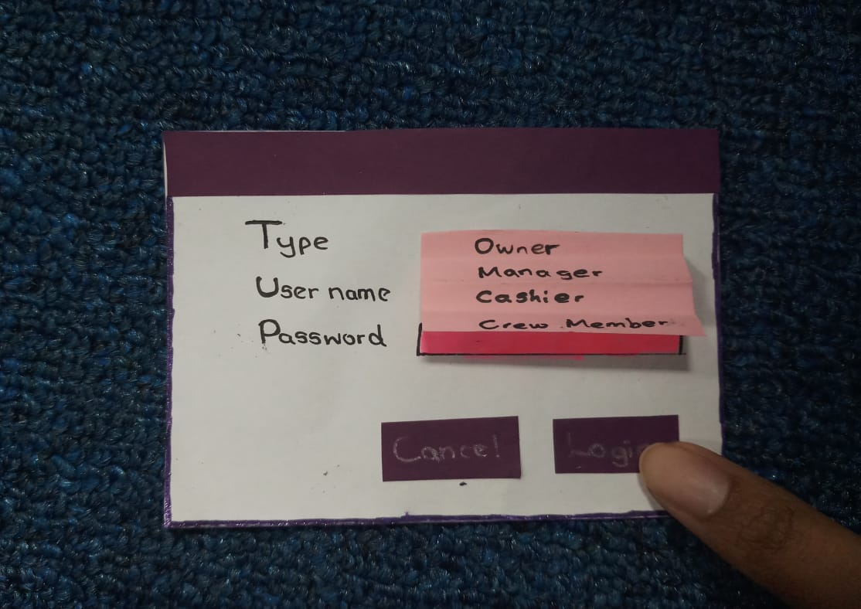

07

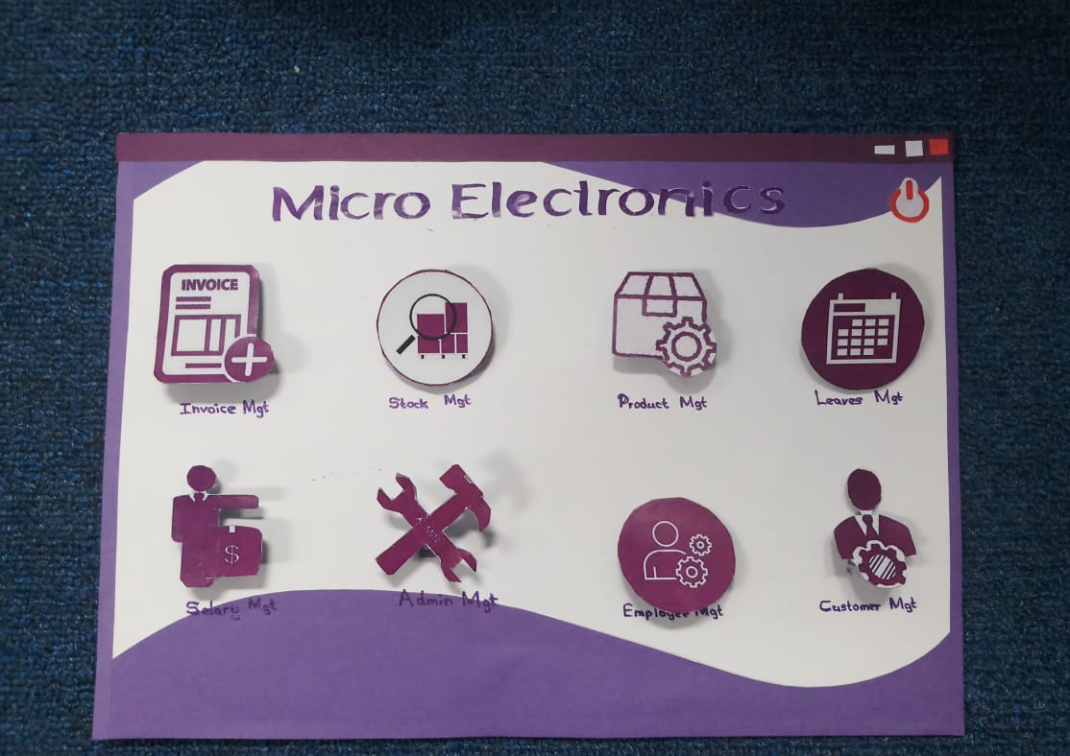

08

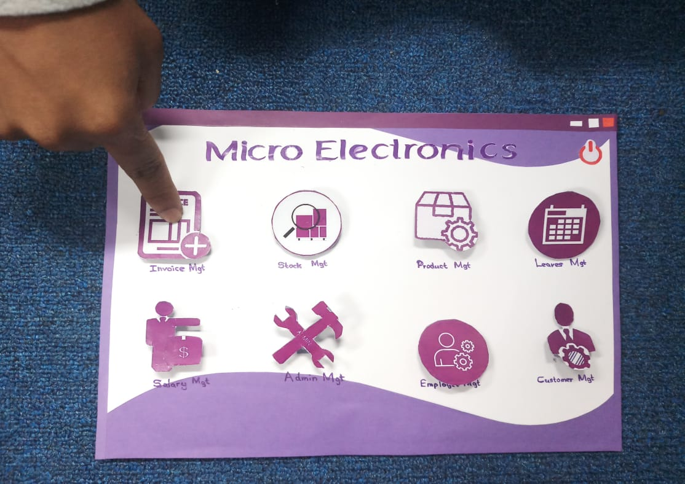

09

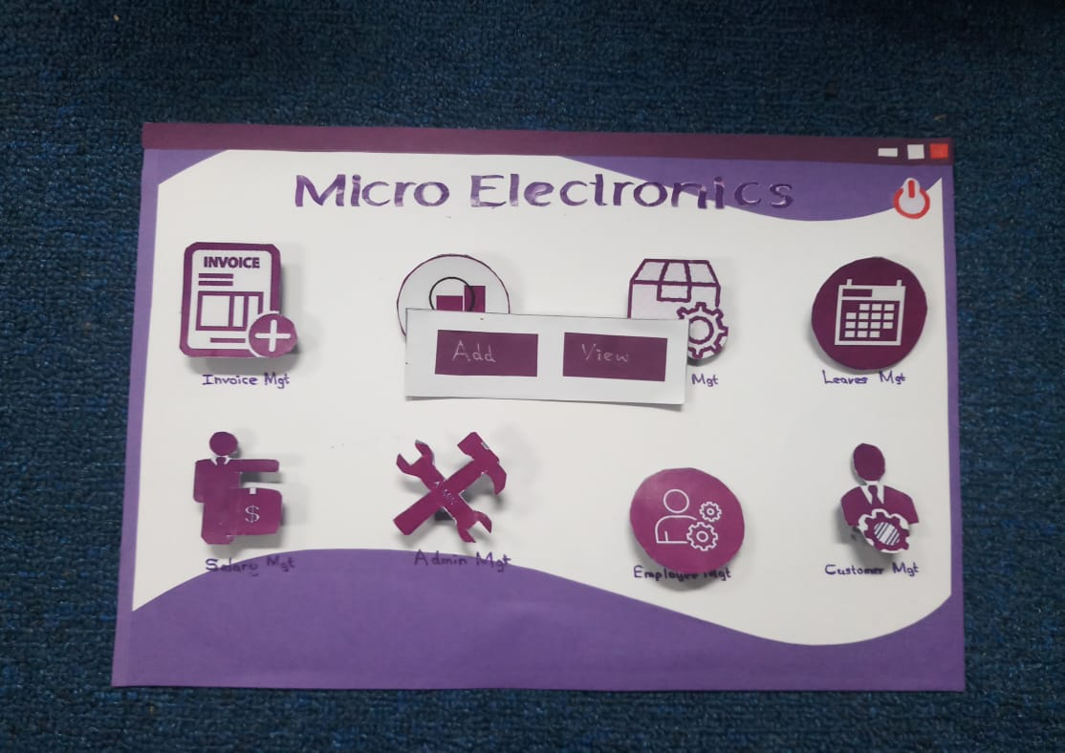

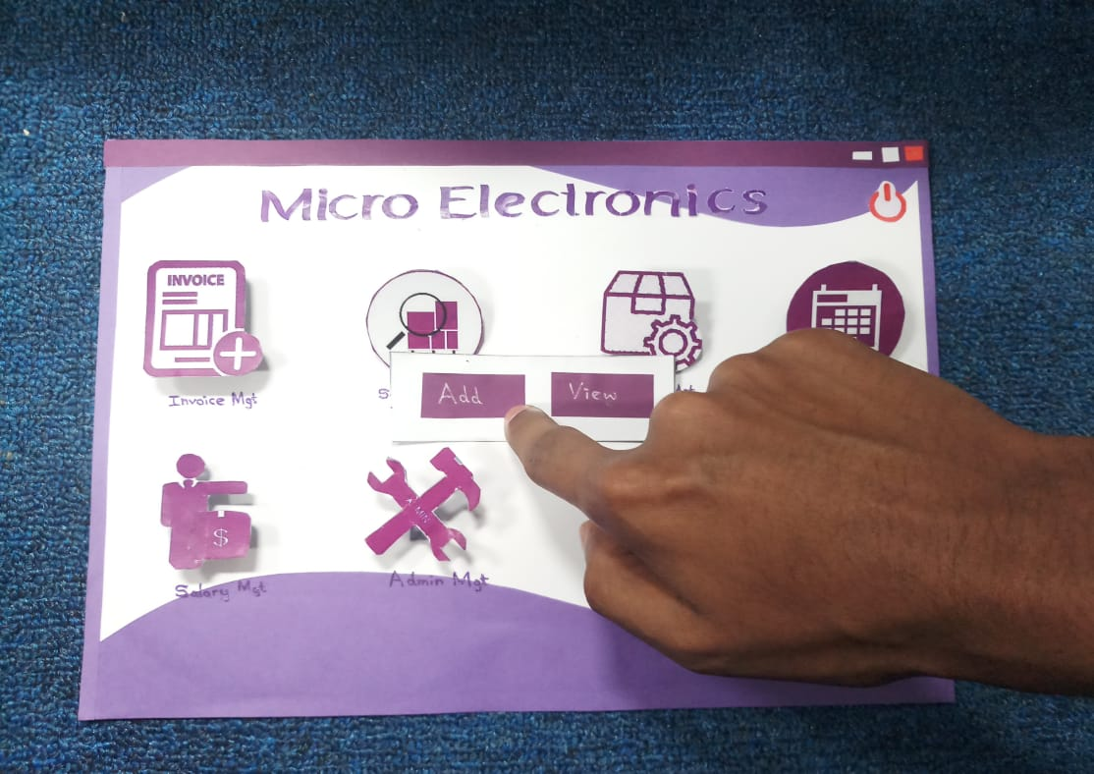

10

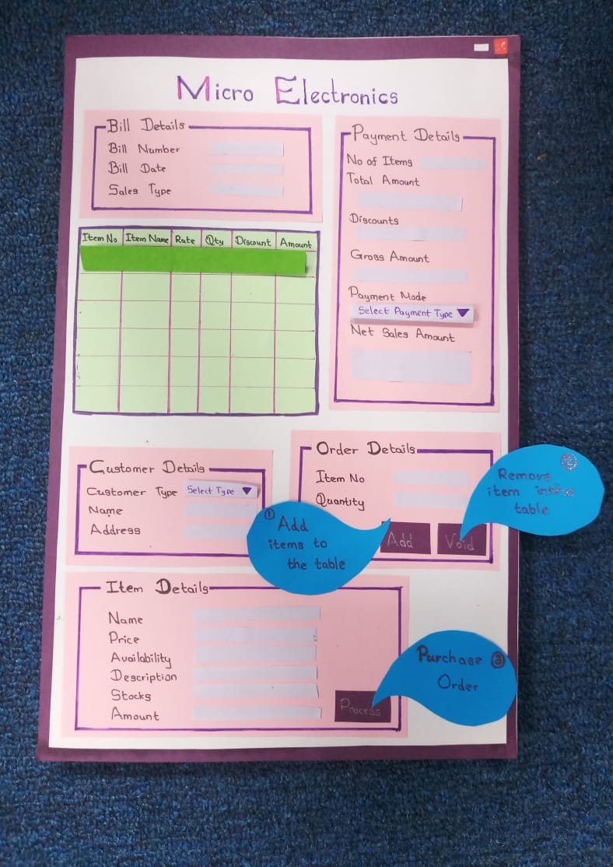

15

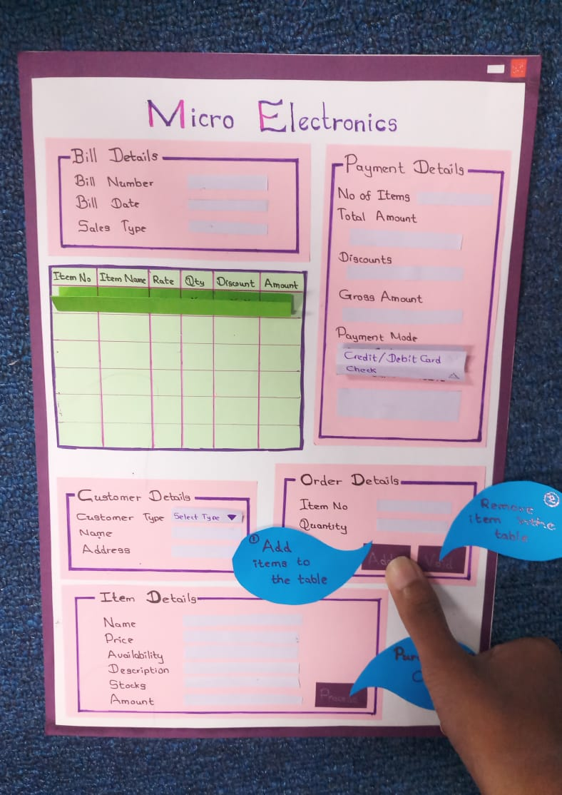

16, 17

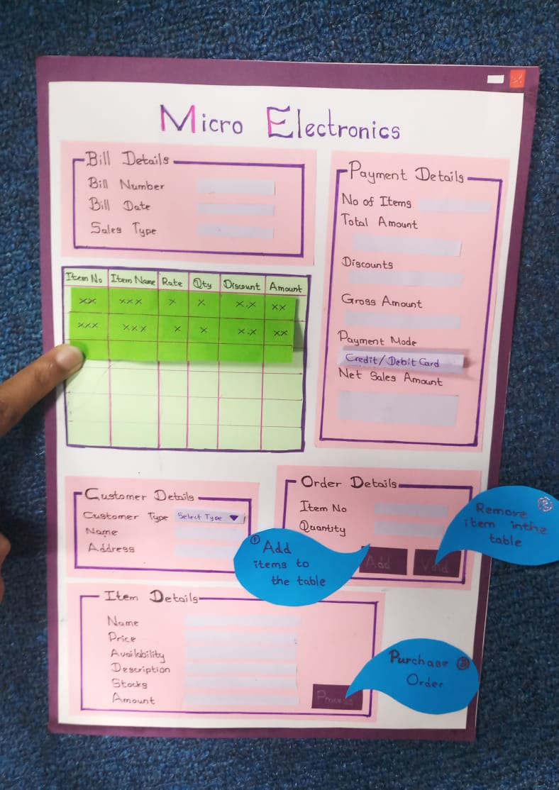

18

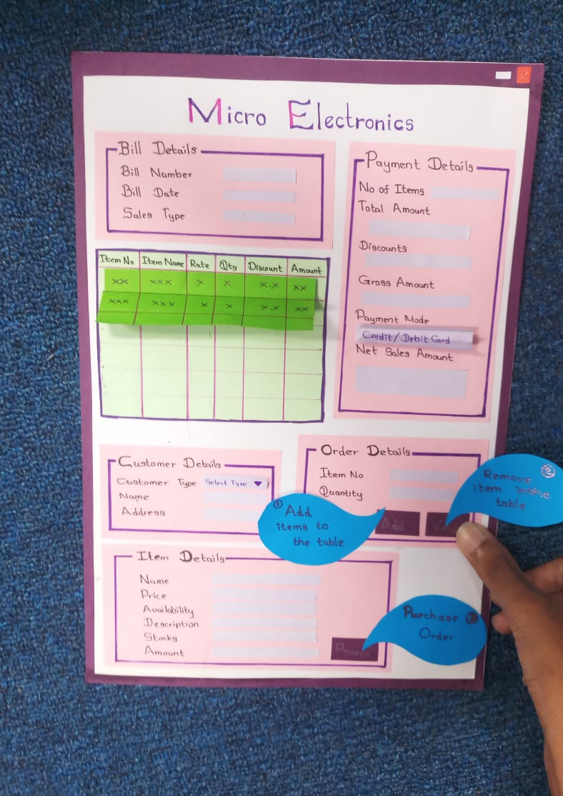

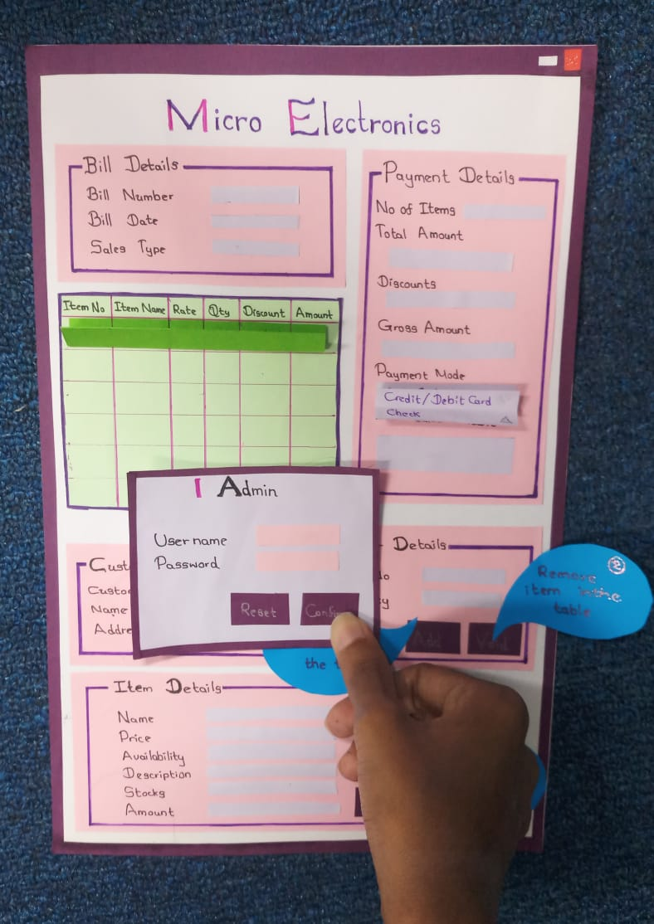

19

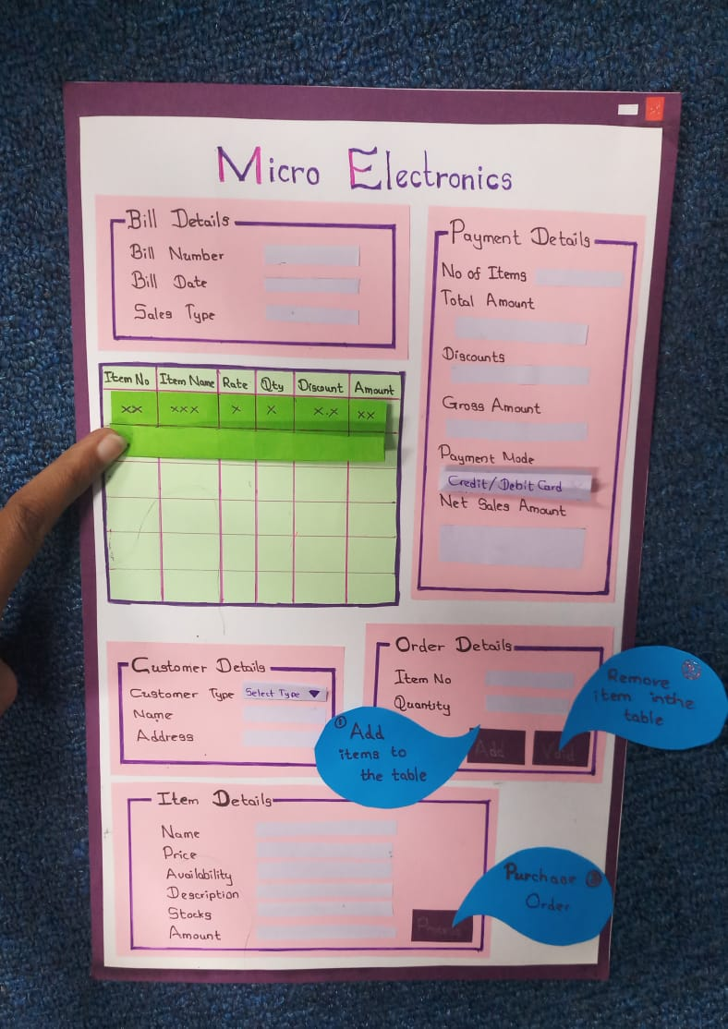

20, 21

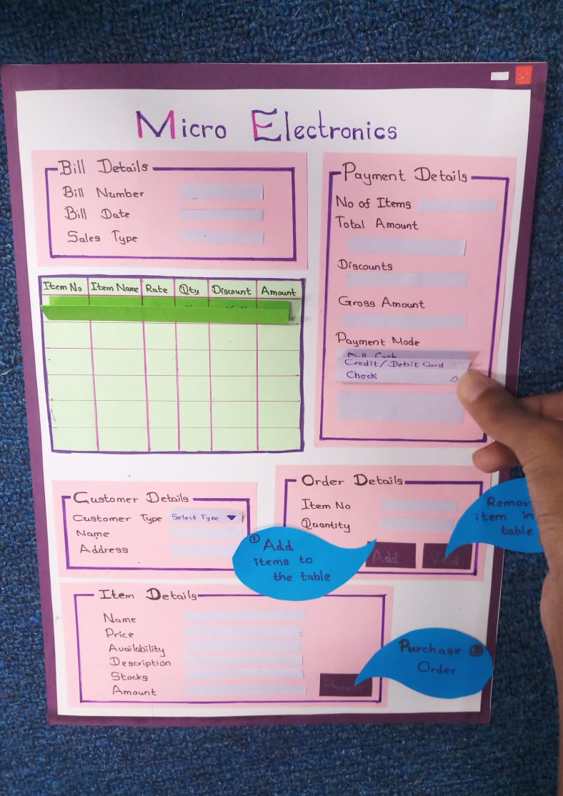

22

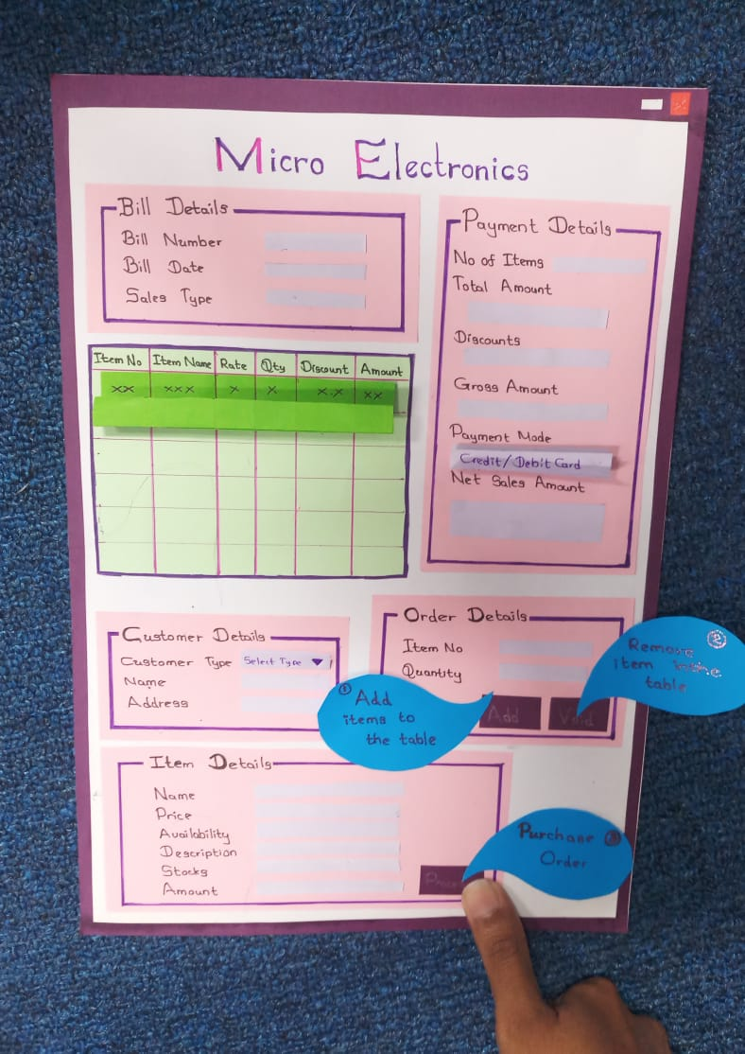

23

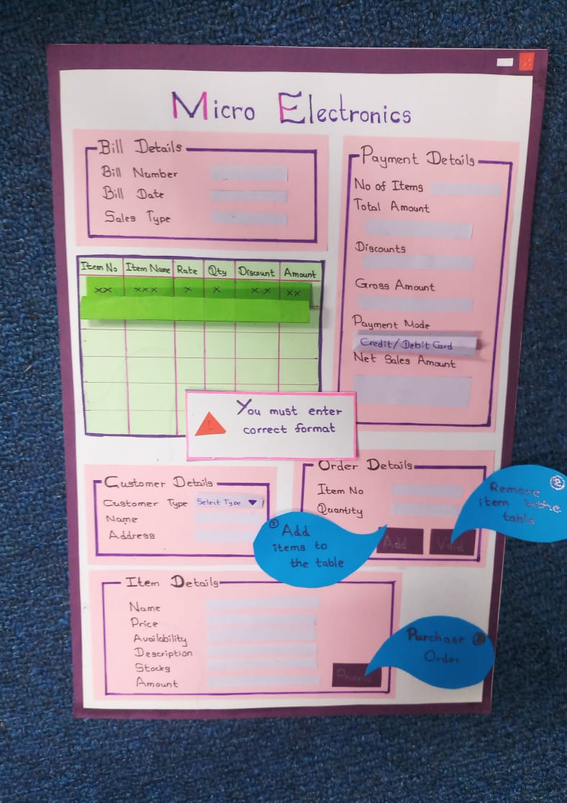

24, 25, 26, 27

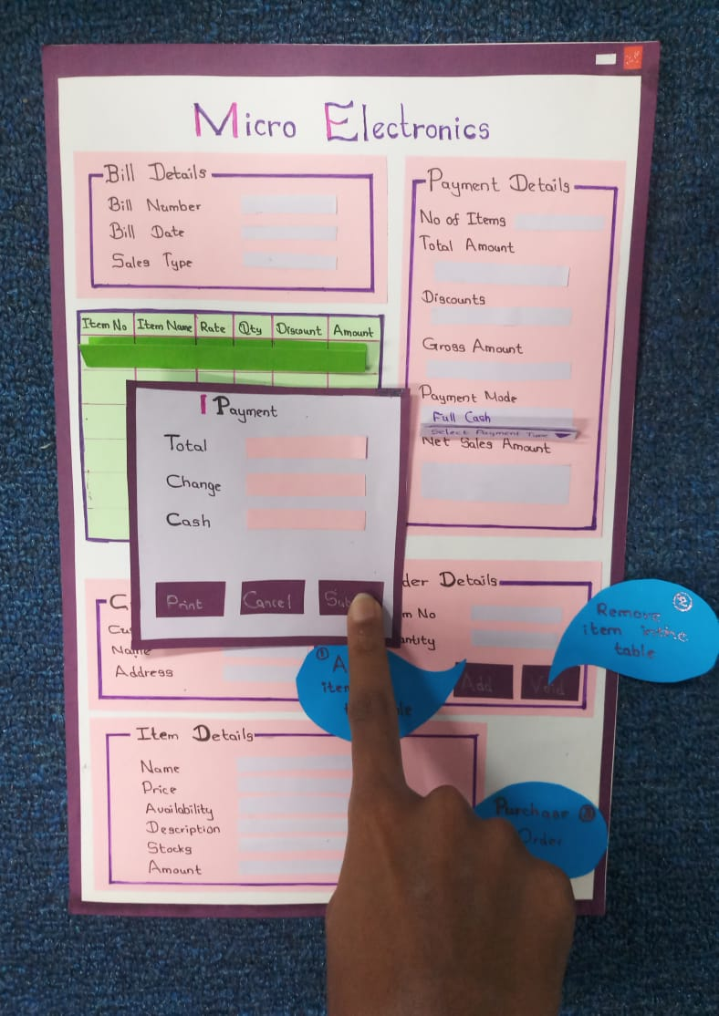

28

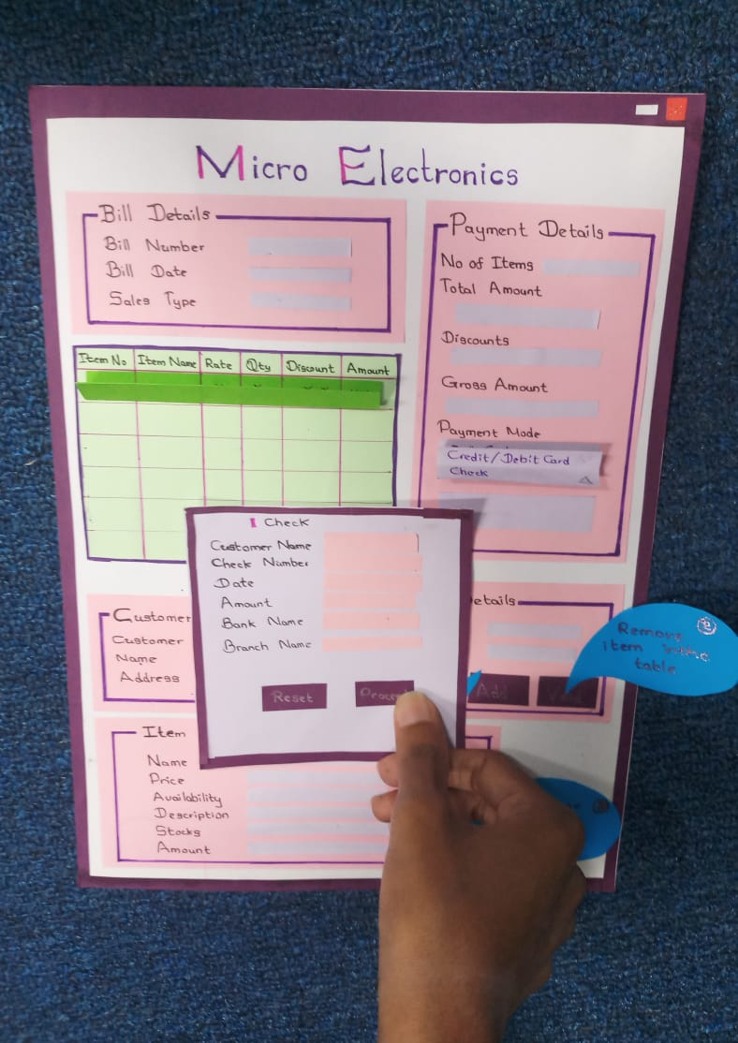

29

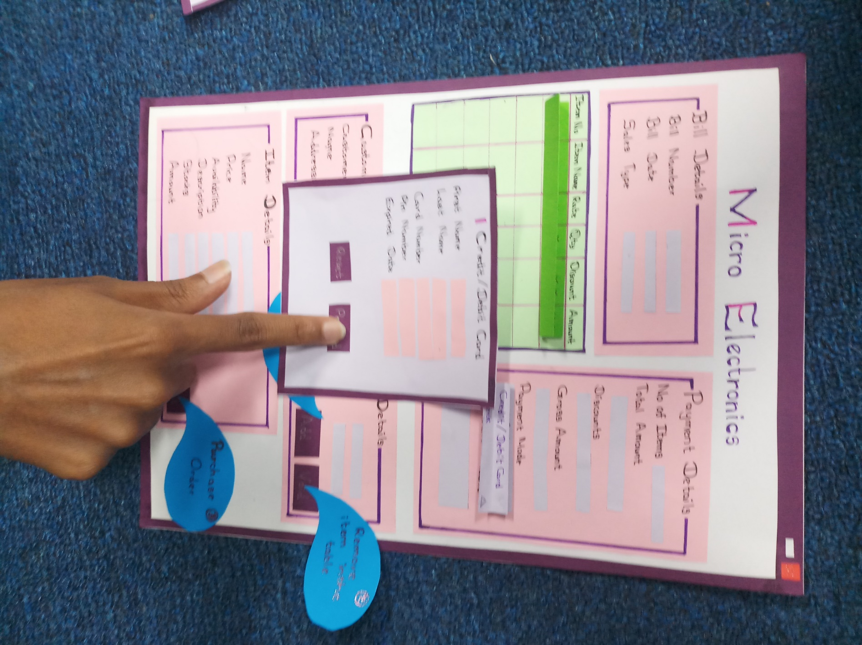

30

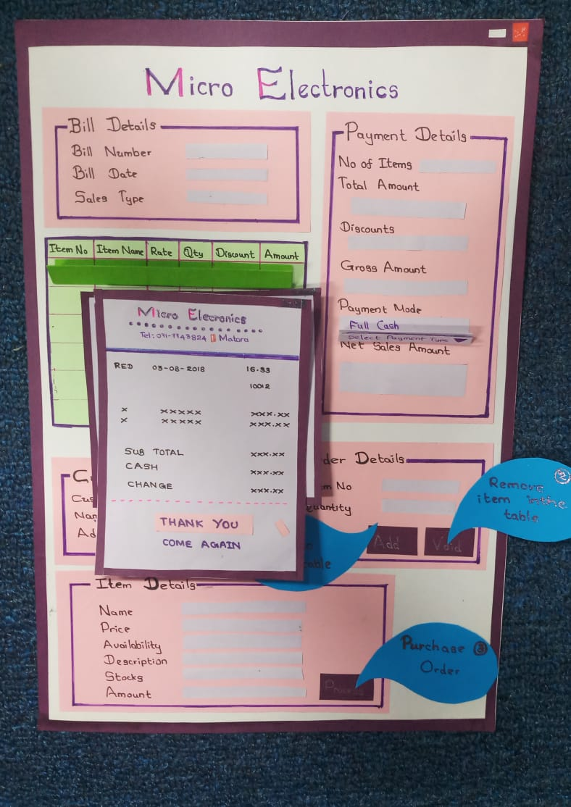

01. Add Employee

1. Loading system.

2. Display Login page.

3. Cashier entering User type.

4. Entering username and password.

5. Checking username and password.

6. Display login successful message.

7. Display home page.

8. Click Employee Management.

9. Enter employee details.

10. Click Add button.

11. Validate the details.

12. Display successful message.

13. Select the relevant employee details to be updated.

14. User updates the needed information.

15. Click the update button.

16. Validate the details.

17. Display successful message.

18. Select the relevant employee details to be deleted.

19. Click the Delete button.

20. Click Back button to the home page.

11.a. If the details entered are not valid ask user to re-enter the relevant details.

8

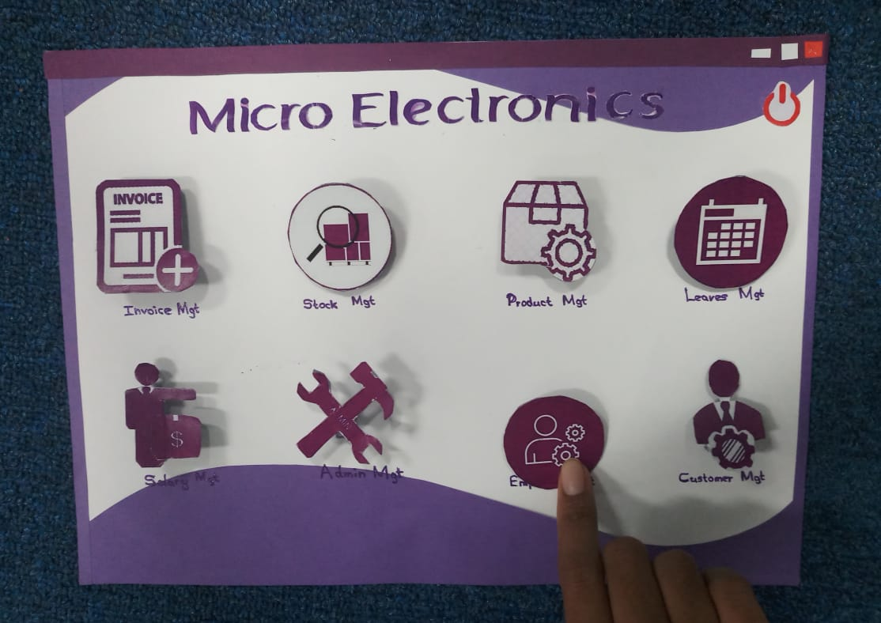

09

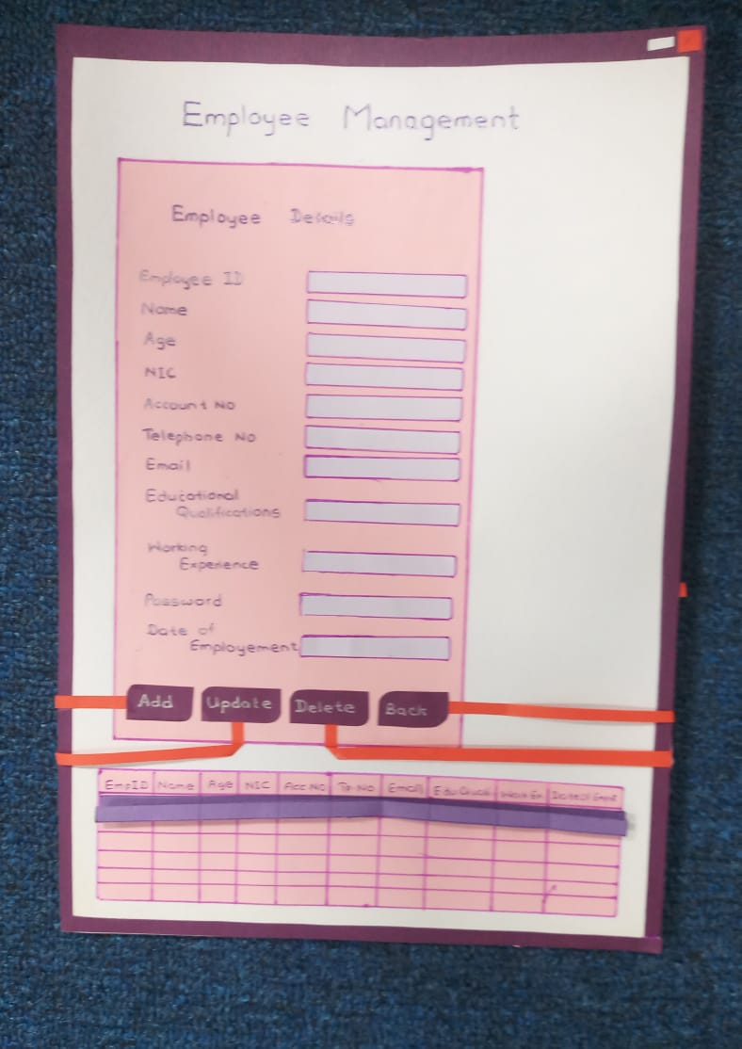

10

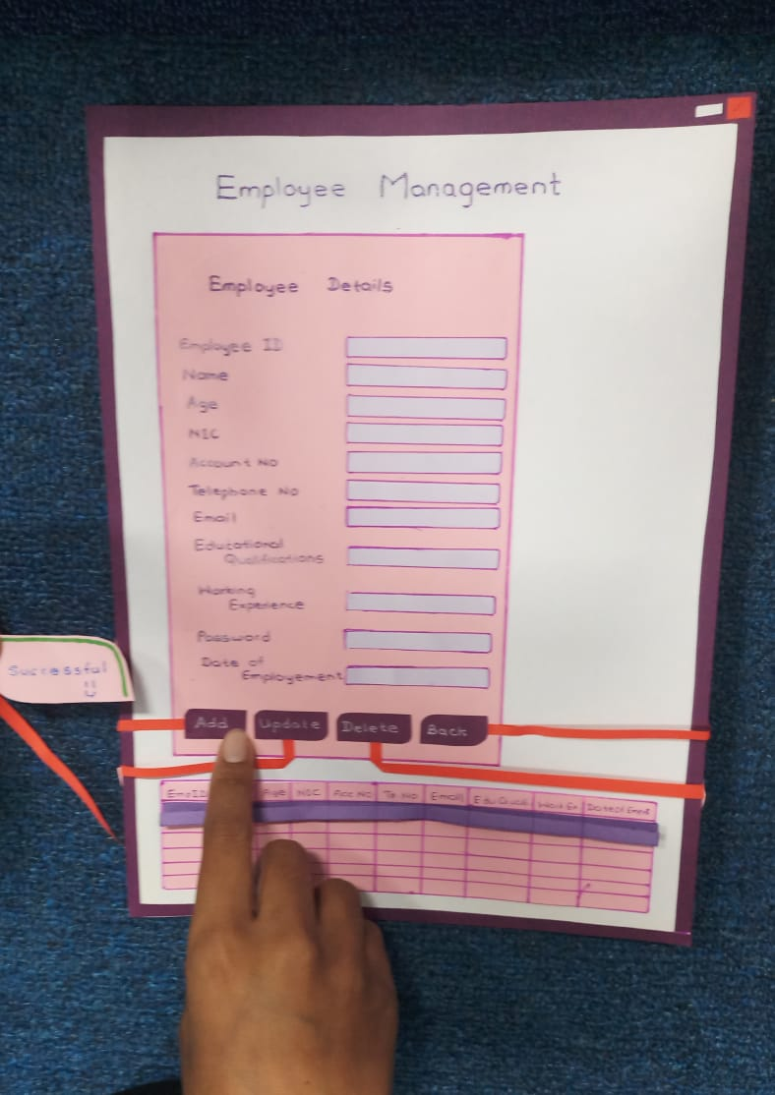

11

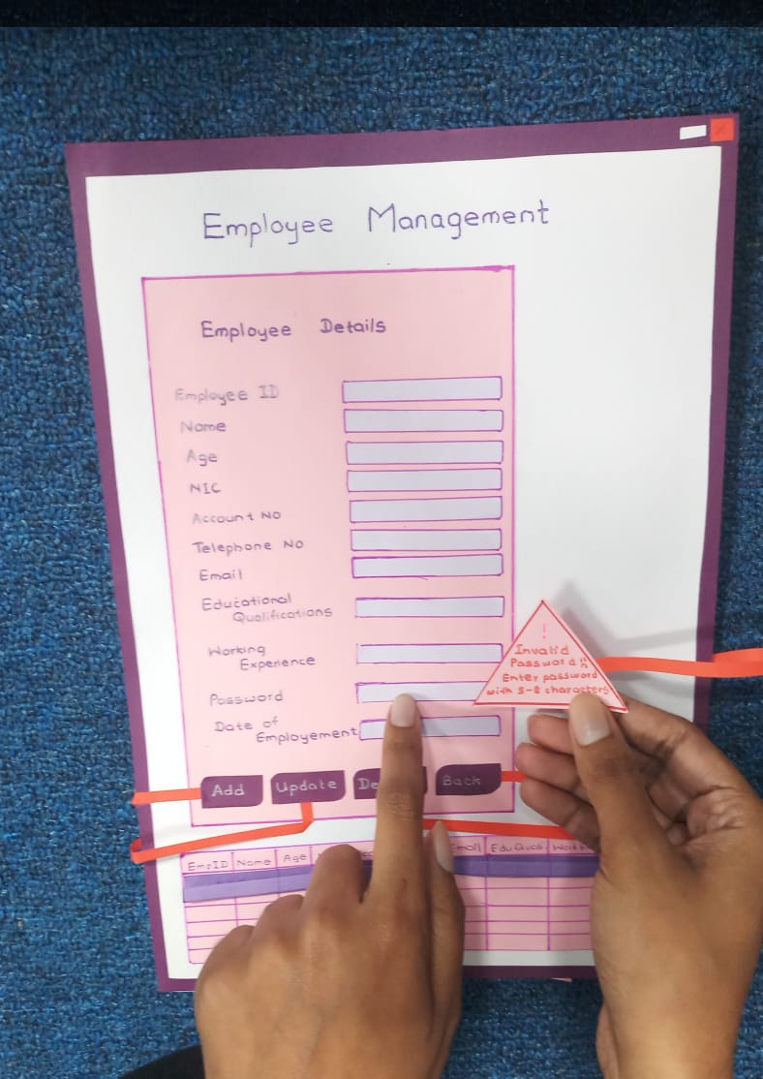

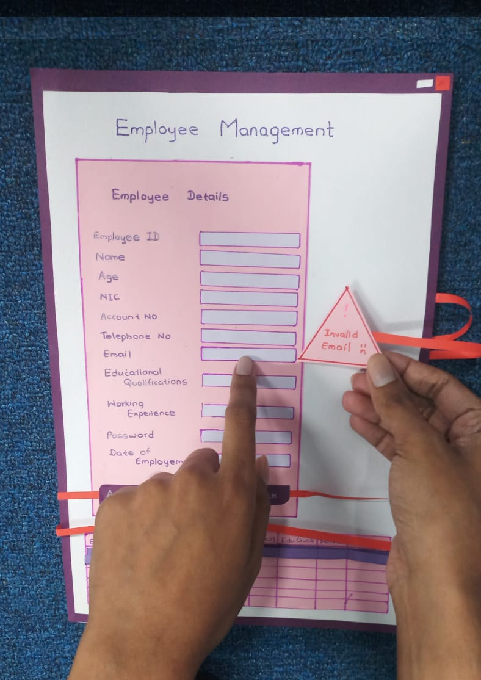

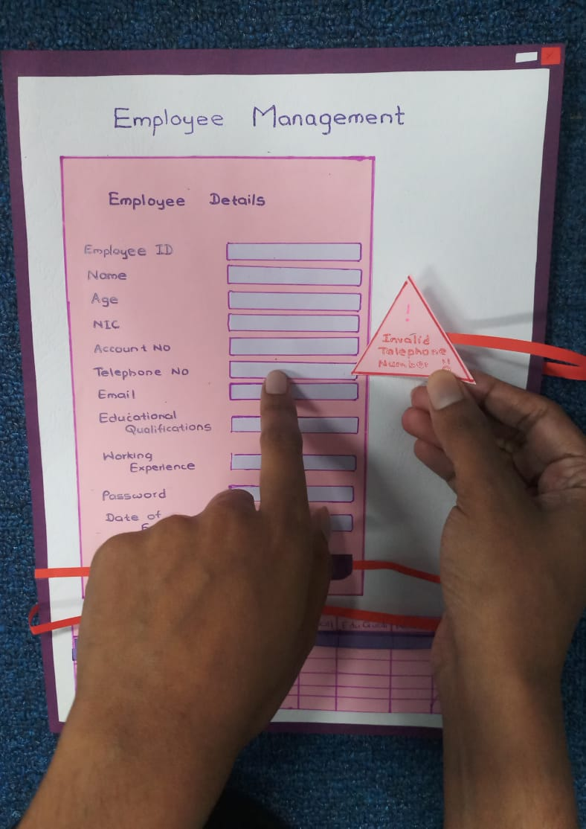

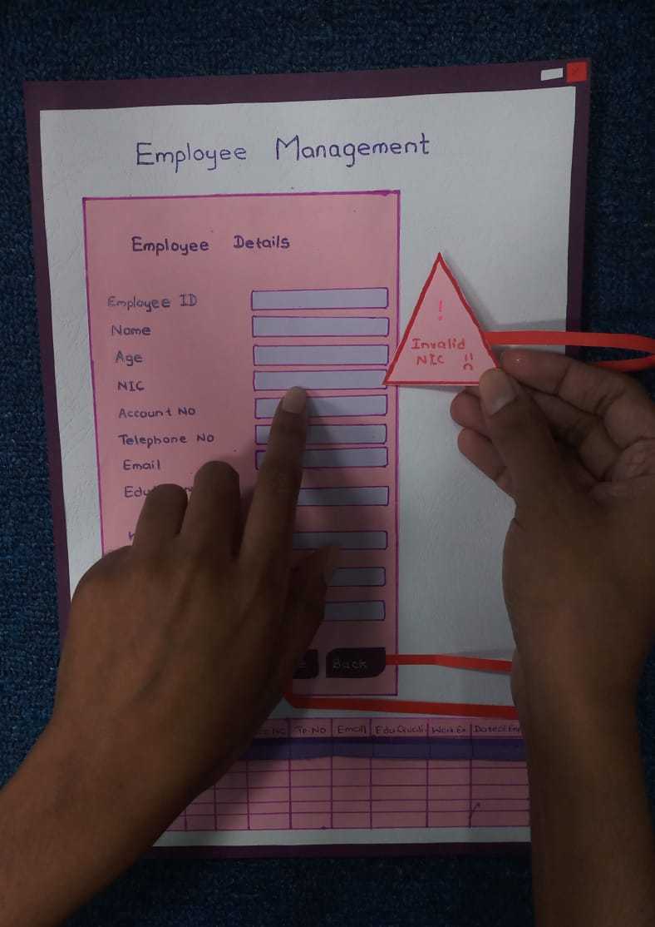

19

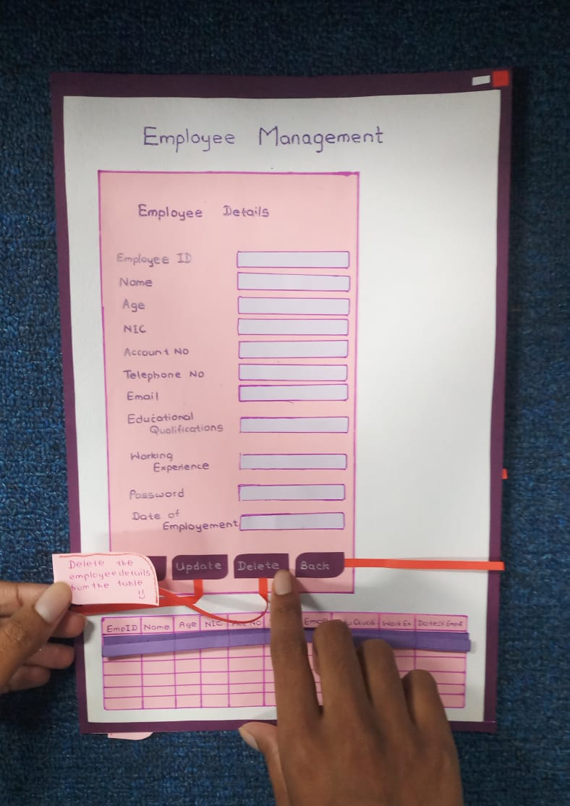

20

